AEPHY2024
Narrogin SHS Year 11 ATAR PHYSICS Name: Solutions
Task No: | 9
Task Type: | Test
Content: | Linear motion and force
Task Description: | Complete the attached questions in the spaces provided.  Marks will be awarded for presentation and working.  Test conditions (60 minutes).  Formulae and data booklet provided.  Non-programmable calculator permitted.
Total Marks: | 45
Weighting: | 6%
Materials required | pens, pencils (including coloured), sharpener, correction fluid, eraser, ruler, highlighters, scientific calculator
Due Date:

Answer the following questions in the spaces provided

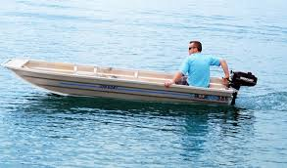
- A boat, that is capable of travelling at 8.0 km h⁻¹ in no current, heads directly across a river that is 1400 m wide. The current is flowing at 6.0 km h⁻¹ at right angles to the boat. What is the boat’s speed in ms⁻¹?

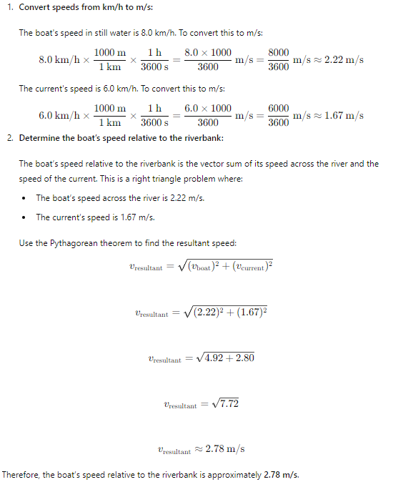

(3 marks)

- A 10kg weight was dropped from a hot air balloon that had an altitude of 3000m. How long did it take for the weight to hit the ground?


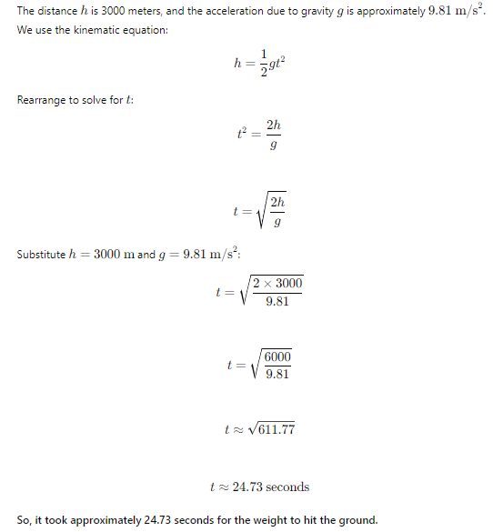

(3 marks)

- A student threw an 80 g ball vertically upwards with a velocity of 25 ms⁻¹. Calculate the maximum height achieved by the ball.


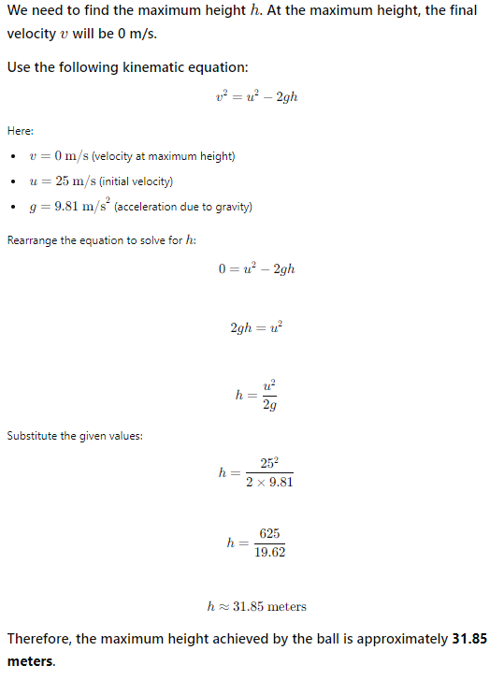

(3 marks)

- A 50 kg go-cart crashes into a 40 kg go-cart which is travelling in the same direction at 1.2 m s⁻¹. The front cart moves off at 1.8 m s⁻¹ while the back cart continues at 1.5 m s⁻¹. Calculate the initial velocity of the 50 kg go-cart.
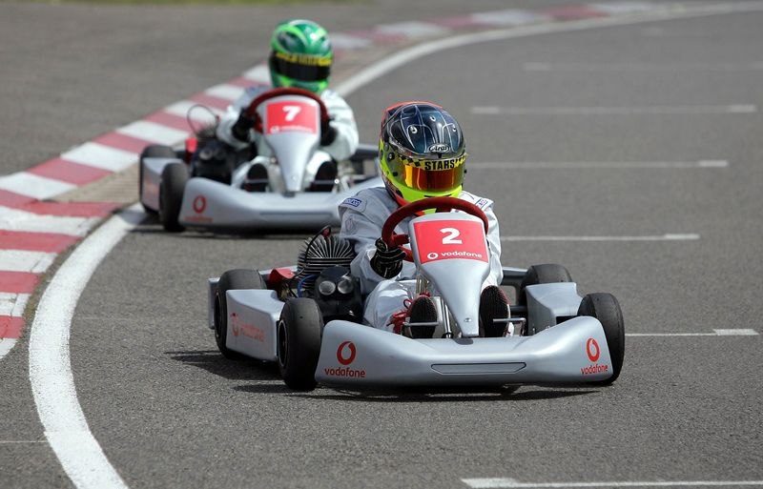

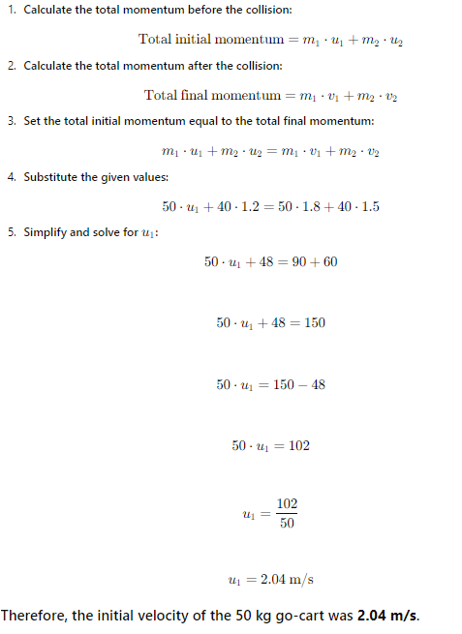

(3 marks)
- An inexperienced engineer designed a rollercoaster track. A rollercoaster starts rolling along a horizontal length of track at 5 ms⁻¹ and 20m above the ground. The car then travels down a sloping part of the track to ground level and then rolls along a level section of track. After 10m of track the rollercoaster car travels up a vertical section of track. You may assume the mass of the car.

Rough diagram:

5 ms⁻¹

20 m

- Sketch a velocity vs. time graph to show the motion of the rollercoaster.

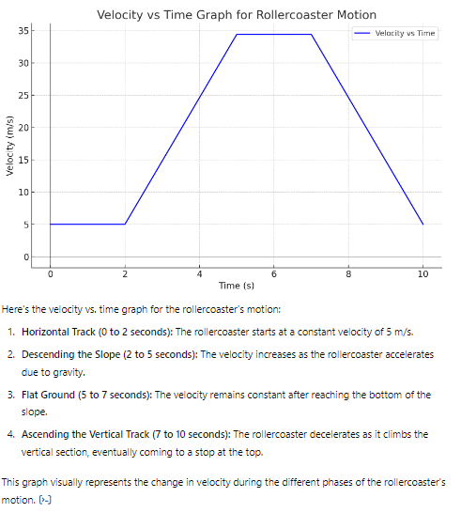

(2 marks)

- How fast is the rollercoaster car travelling at the bottom of the slope?

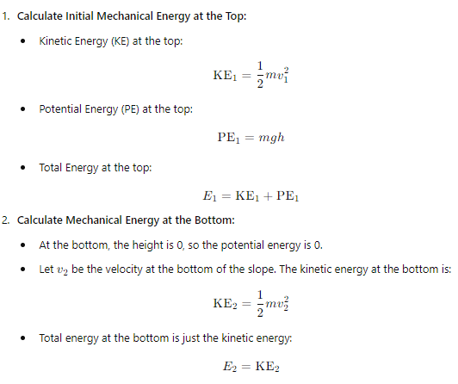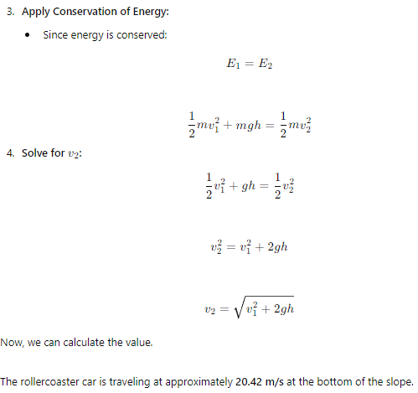

(3 marks)

- How high up the vertical section will the car travel before it rolls back down towards the ground section?
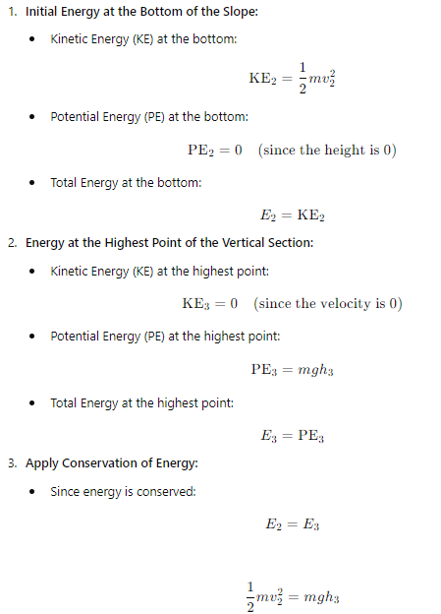

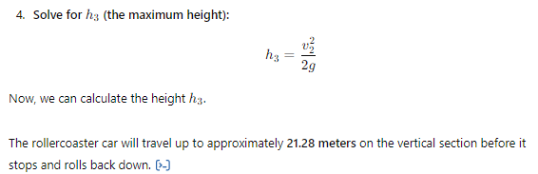

(3 marks)
- An electrical engineer is designing a winch that is to be used for lifting heavy mining carts up a vertical shaft. The carts will have a maximum weight of 800 kg and the shaft is 400 m deep.
The winch needs to be powerful enough to lift the cart up 400 m in 2 minutes.
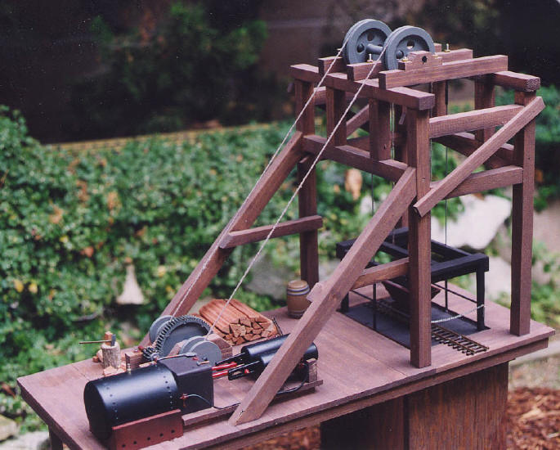

- Calculate the amount of energy needed to lift one cart that is loaded to the maximum limit.

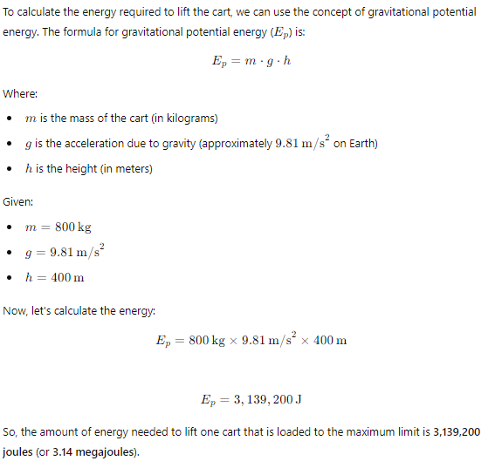

(3 marks)

- Calculate the minimum power rating of the winch

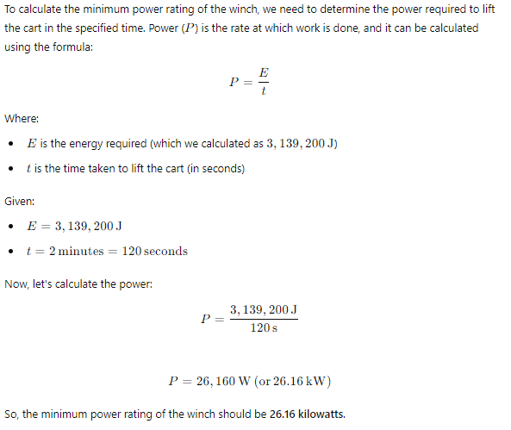

(2 marks)

- A F1 car (440 kg) travelling at 200 km h⁻¹ can come to a complete stop in 2.21 seconds.

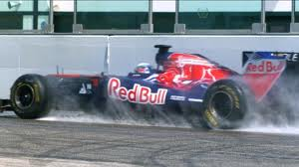

- Calculate the amount of force needed to slow the car down.

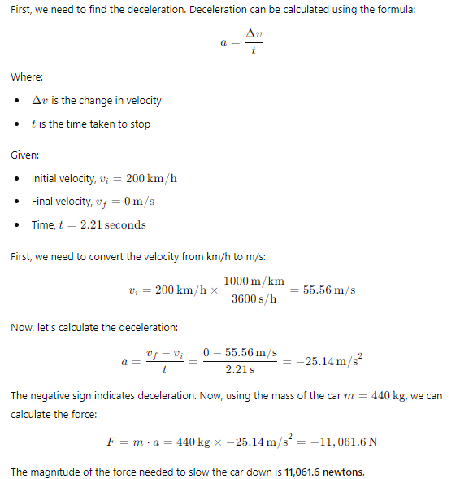

(2 marks)

- Determine the braking distance (not including driver reaction time)

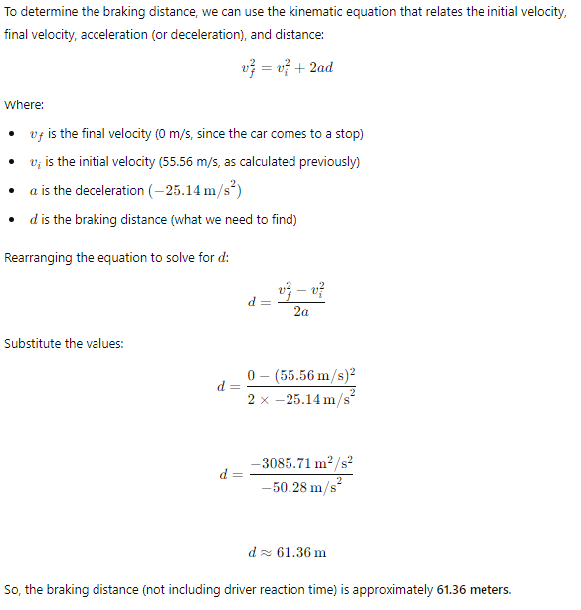

(3 marks)

8. A kg undercover police car is travelling at m s⁻¹ when another car speeds past it, travelling at a constant speed of m s⁻¹. The police car immediately begins pursuing the second car, accelerating at a constant rate of m s⁻².

(a) Determine the magnitude of the initial momentum of the police car.
(1 mark)
(b) Determine the police car’s speed after 2.00 s of accelerating.
(1 mark)
1 mark
(c) At the time when the police car’s speed matches that of the speeding car, determine the distance between them.
(5 marks)

 | 1 mark
s | 1 mark
m | 1 mark
m | 1 mark
m | 1 mark

(d) Determine how long it takes for the police car to catch up to the speeding car (from the time the speeding car first passed the police car).
(3 marks)

 | 1 mark
 | 1 mark
s | 1 mark

(e) Determine the average power of the police car during its pursuit.
(3 marks)
Average speed of the police car is  (needs to equal the average speed of the speeding car, or by considering parts d and e) | 1 mark
N | 1 mark
W | 1 mark

(f) Once caught, the speeding car begins to slow down to a stop, braking at a constant rate of 7.00 m s⁻². Determine the distance over which it brakes.
(2 marks)
 | 1 mark
m | 1 mark

END OF TEST

